Method to Assess Climate Change Risks in Buildings

Abstract - In response to a business demand for a simple risk assessment method for assessing potential climate change and sustainability risks in existing commercial properties, a bespoke assessment method was created. The process is described within the paper.
Following a literature review and evaluation of existing property assessment methodologies, an excel based assessment and reporting tool was created with a set of 12 risk criteria, each with multiple bespoke sub- issues, resulting in 67 no. issues in total. A scoring system was developed where Net Risk value is calculated as the Gross Risk modified by the effectiveness of any current Control Measures, with Gross Risk calculated as: the likelihood of exposure to a risk multiplied by the potential impact (both scored on a 1-5 scale), thus providing a quantifiable Net Risk score.
The results of the risk assessment and built in recommended mitigation measures are used to advise on a mitigation programme with the aim to: improve resilience, lower potential future risk and guide financial decision making within existing properties.
Key words – Buildings, Assessment methodology, Sustainability, Property, Risk model, Mitigation

Introduction
A changing global climate poses multiple and significant risks to existing property portfolios (1). This paper describes a bespoke assessment methodology that was developed to quantify potential risks and provide recommended mitigation measures for existing commercial property, principally UK-focused but globally applicable.
When considering commercial property decisions, timeframes are often multi-decadal. Therefore investors, owners and occupiers are increasingly expecting new construction projects to consider potential future risks related to sustainability and climate (2). Long term sustainability considerations are also a consideration at a national level, reflected in minimum building standards and planning regulations. Furthermore, construction assessment methods, such as LEED, BREEAM, SKA and WELL, are increasingly being applied (3), either voluntarily or as a legislative planning requirement, providing a quantifiable measure of building performance for newly constructed or refurbished assets.
It has been noted that in Europe and North America few standardised methodologies exist for assessing risk in existing properties (4). Operators in the commercial property sector recognised a market demand for a simple assessment method that is less onerous than extensive formal assessment, yet provides insight into risk exposure and guide potential mitigation for existing properties.
In response, a straightforward assessment methodology was developed to: quantify the likelihood and impact of potential climate change and sustainability risks; assess current mitigation measures and produce a net risk value for a number of key issues. Targeted at guiding early intervention, the information produced is also of benefit for financial considerations, investments, insurance considerations and negotiating lease agreements.
An easy to use Excel-based assessment and reporting method was designed for use by Building/Facility Managers (FM), or similar professionals, to undertake the assessment process, with guidance from appropriate expertise where necessary. This paper will describe the process undertaken in creating the assessment, the outputs and the lessons learned.

Methodical Approach
Assessment Scope
The initial scope was to identify building performance at multiple individual commercial office properties against a set of predetermined risk criteria, in order to quantify the likelihood and impact of the potential risk, including any mitigation present. This would be achieved by generating an output which identifies potential risks to the property and/or business operations with potential to negatively affect performance, then support measures to reduce risk.

Research and Literature review
A literature review of sustainable construction methodologies, climate change risks and building management resources was undertaken, focusing on existing UK/US/EU regional and national built environment risk assessments and property climate change and sustainability assessment formats (5) (6). A bespoke list of risk assessment issues were created based on the reoccurring themes within the literature review.
Climate change and sustainability risks are both global and interconnected. Therefore, simple consideration of local physical weather changes, although often a significant factor, may lead to not considering the localised environmental and social impacts as a consequence of climate change effects on wider regional and international scales. For example, it is expected that by 2050 there will be between 200 million to 1 billion climate refugees globally (7); causing potential direct and indirect impacts on the property/organisation being assessed through changes in social dynamics, political environment and wealth distribution, thus creating potential risks worthy of consideration.

Identification of Key Risk Issues
A comprehensive set of risk factors were determined based upon 12 Risk Criteria, with a number of regional bespoke sub-issues for each, see Table 1.

Table 1: List of risk assessment issues, description and number of sub-issues
Issue | Description | No. sub-issues assessed
Energy Efficiency | Risk of higher fuel costs, energy security issues, associated negative environmental externalities. |  | 6
Water Efficiency | Increasing demands on water, changes in precipitation patterns and additional environmental protection legislation may lead to reduced availability (with potential restrictions on use), higher water costs and greater environmental impact from extraction and waste water treatment. |  | 7
GHG Emissions | Associated extraneous impacts from emissions; likely increases in legislative controls, reporting requirements and stricter emission requirements; impact from reputational expectations and damages; greater consideration of GHG emissions when accessing finance and valuation of an asset. |  | 5
Building Safety & Materials | Structural integrity of asset, potential for increased maintenance costs, loss of business continuity and income from major disruptions, potential for whole building to be unsuitable for occupation. |  | 7
Transportation | Increasing fuel costs, pollution emission controls and congestion could affect ability of staff and products to get to and from the asset. |  | 6
Contamination | Site and building has potential to cause environmental damage or effect human health, with associated business liabilities and potential risks of legislative and financial implications if site causes negative environmental/human health effects. |  | 4
Natural Hazards | Direct risk of natural hazards impacting on the asset and its operation; risk of increasing difficulty in obtaining finance, greater insurance costs, lower rental income potential, disruption to business continuity. |  | 4
Climate Change | Unknown consequences of changing climate on asset physical structure, access to resources, impact on business operations. Greater legislative and reporting requirements with financial and legal consequences. |  | 6
Socio-economic | Assets and organisations operate within the wider social and economic environment, both influencing and being influenced by it. The socio-economic environment can offer potential opportunities and risks. |  | 9
Regulatory | Risk from legal impacts, reputational losses, additional charges, costs and fines. |  | 3
H&S and Wellbeing | Risks of legislative non-compliance, lower rates of productivity, asset value and exposure to litigation. |  | 9
Other | Risk of changing pattern of engagement from internal stakeholders. |  | 1

Creation of Assessment Methodology
An Excel workbook was created for each property assessment. Each workbook has the following sections:
- Introduction text – brief outline of the assessment; site information; audit details, purpose and approach.
- Results summary – Gross Risk, Net Risk and Normalised Risk output for each assessment issue with recommendations;
- Assessment issues overview – description of each Risk Criteria;
- Method – description of key terms, assessment instructions, recommended reading prior to an assessment and guidance;
- Individual assessment and scores – each assessment issue has a specific assessment tab (see Figure 1 for an example);
- Graphs – visual representation summary of the risk assessment scores including Gross and Net risk; and
- Data tab – optional input tab to store assessment data, such as energy use, water use and other quantifiable metrics for reference.

The layout, scale and size of the Excel workbook was designed to be outputted as a standard A4 (US ‘letter’ paper size) report style format, PDF and printer compatible, with the intention to be easily included in building information records, corporate reporting or due diligence portfolios.
An example of the layout for each assessment issue can be seen in Figure 1. Following feedback, the current iteration has a single assessment reporting and scoring sheet. This was found to be the most effective way to engage relevant stakeholders, as the logic behind the issue, scoring and the proposed mitigation can easily be followed through, creating greater ‘buy in’ for intervention.

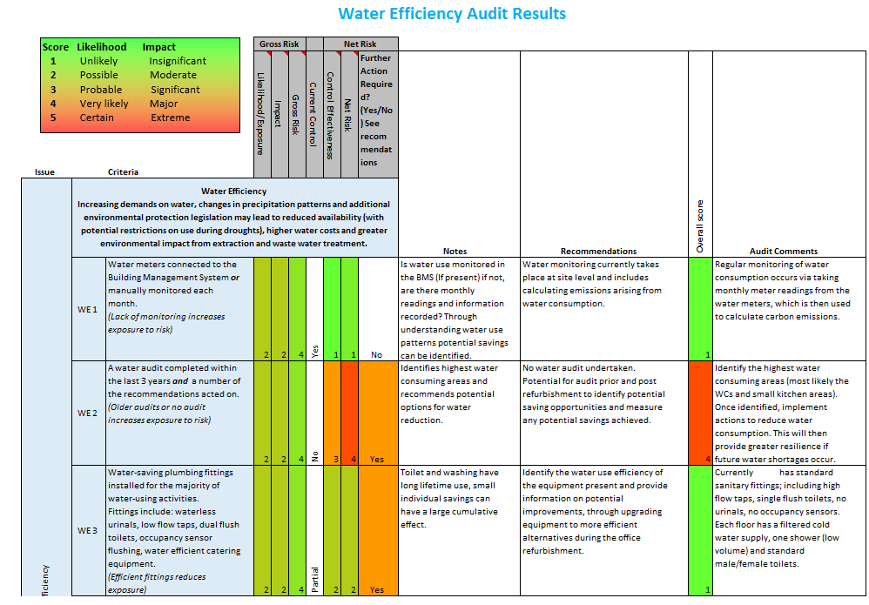

Figure 1: Screen shot from the Excel assessment showing the layout and example responses/scoring.

Scoring Methodology
Each Risk Criteria is made up of multiple sub-issues which address a specific concern, risk or best practice. Each of the sub-issues has: an evidence criteria, description notes explaining the risk posed and suggested recommended mitigation actions.
For each applicable sub-issue, the level of risk (Net risk) is determined using the following standard approach.
Equation 1:

Gross Risk (likelihood × impact)
Net Risk =
Current control effectiveness

Where:
Gross Risk is the sum of the likelihood score and the impact factors, which are defined as:
- Likelihood/Exposure: how likely the risk is to occur or how exposed the building/organisation is perceived to be. Scored on a scale from 1-5 (unlikely, possible, probable, very likely, certain).
- Impact - the potential magnitude of impact the issue may have on the building/organisation if the sub-issue occurred. Scored on a scale of 1 to 5 (insignificant, moderate, significant, major, extreme).
Current Control - if there is currently a control mechanism in place which is deemed to reduce the exposure or impact of the risk. Scored as: Full, Partial, or No control.
Net Risk – the Gross risk modified by the level of Current Control effectiveness - if there is a complete (full) control mechanism in place (‘Yes’ in control box) the risk is deemed to be controlled (thus removing the risk to a minimum score of 1); ‘Partial’ control is where there is a control in place but it is deemed to only partially control the issue (halves the Gross Risk score); ‘No’ control is deemed that there are no effective controls currently in place, or those present are deemed to offer an inadequate level of control, (no impact on the Gross Risk score).
Normalised Risk - displayed in results tab, identifies a specific key risk issue which is deemed to be of much higher risk than the others, therefore should be a focus of further work, mitigation or assessment. Calculated as the issue’s total Net Risk / count of sub-issue categories.

Assessment Process
Once the specific risk sub-issues have been finalised for the site, information is requested for the relevant evidence prior to undertaking a site audit. Evidence viewed should be verified and recorded within the assessment tool for reference and provide an audit trail. It is important that evidence is retained and stored appropriately, depending on appropriate business sensitivity. This allows for follow up assessments or use as evidence in other assessment or reporting frameworks. Site audits should be carried out or supervised by sufficiently qualified individuals; accurately recorded; and used as a verification exercise, assessing specific sub-issues and discussing potential risks with appropriate stakeholders.
Once all issues have been satisfactorily audited and the results collated, recommendations for mitigation can be considered in line with industry best practice, guidance and expert opinion. When considering mitigation having input from key stakeholders is often important in creating realistic and achievable solutions, as well as achieving a greater success rate of buy in (8).

Learning points
Key learning points taken from the project include:
- Although intentionally designed to be simple and easy to use, the assessor needs to be suitably knowledgeable. It was found that greater value can be obtained from an experienced and/or qualified assessor;
- Using a 1-5 risk assessment scale and 3 levels of current control, maintains simplicity without too great a loss of specificity;
- Issues of subjectivity between individual assessors was found. There is a need for internal checks and controls to ensure consistency; and
- Assessment results are useful as an initial assessment of overall risk, further due diligence of individual findings are recommended prior to financial decisions.
The following advantages to undertaking a sustainability audit have been recorded from user feedback:
- Measure and improve business resilience to potential future risks;
- Increased investment assurance in long term viability;
- Improved occupier satisfaction and/or potential productivity of staff;
- Recognition in assessment frameworks, such as Global Real Estate Sustainability Benchmark (GRESB), European Public Real Estate Association (EPRA);
- Provide a competitive advantage;
- Lower financing costs, insurance premiums (financial institutions are beginning to offer favourable rates for buildings deemed as lower risk);
- Increase retail or lease value;
- Reputational advantage through promotion of sustainable behaviours;
- Stay ahead of potential new legislative changes, issues and corporate goals;
- Provide a focused approach to risk mitigation and intervention measures; and
- Track progress in risk reduction.

Conclusions
There is significant potential for improvement in the existing property sector through the use of relatively quick and easy assessments focusing on a broad range of sustainability and climate change related risks. Creation of bespoke risk assessment methodologies are achievable at an organisational level and offer significant business benefits.

Bibliography
1. Climate Change: Implications for Buildings. Chalmers. 2014, IPCC 5th Assessment report.
2. Sustainable real estate investment Impmenting the Paris Climate Agreement: An action framework . P., Bosteels T. & Sweatman. Climate & Strategy Partners.
3. Global Investor Survey on Climate Change. Annual Report on Action and Progress 2010. IIGCC. s.l. : Global Investor Coalition, 2010.
4. Assessing the cliamte change adaptability of buildings. al, Malay D. et. s.l. : NCCARF, 2012.
5. Assessing Current Climate Risks. R., Jones. R and Boer. s.l. : UNFCCC, 2015.
6. Current knowledge on relevant methodologies and data requirements as well as lessons learned and gaps identified at different levels, in assessing the risk of loss and damage associated with the adverse effects of climate change. Surminski S., Lopez A,. Birkmann J., Welle T. s.l. : UNFCCC, 2012.
7. Crisis or adaptation? Migration and climate change in a context of high mobility. Tacoli. s.l. : IIED, 2009.
8. Stakeholder Involvement in Decision Making: A Short Guide to Issues, Approaches and Resources. OECD. s.l. : OECD, 2015.

